Test PCB V3.2 – Oct 2021 Arusha
Everytime the 5V DC charger is removed, the PCB doesn’t not work anymore in standalone mode. The problem can be reset by disconnecting and reconnecting the battery,

Quick fixed applied waiting to have the design improved : Removing Q4, the PCB are then not powered during battery charging but they can work in stand-alone mode.

Multimeter measurements (David, 04.10.2021) :

Power consumption (PCB v3, #1, no sleepmode) - PCB Activated - battery at 3.2v
- nothing on, 0.03 A
- Light level 1, 2 & 3 : 0.06 A, 0.13 A, 0.60 A
- OK

Check phone charging: USB1 & USB 2 : ~5V, 0.5A for phone 1, 1A for phone 2 OK

Check phone charging efficiency :

From battery : 0.95 [A], 3.18 [V], 3.02 [W]
To Phone : 0.49 [A], 5.09 [V], 2.49 [W]
Efficiency : 82.5% (including loss for PCB consumption) => Boost efficiency ~85%, OK.
PCB battery charging circuit efficiency (TP5000 + cable losses) :

Initial battery voltage (light off, no charging) : 3.29V
From 5V power supply : 0.76 [A], 5.0 [V], 3.8 [W]
To Battery : 0.9 A, 3.34 V, 3.0 W
Including all cable losses, battery charging efficiency ~79%, OK.

*without the multimeter to measure current, Charging Power : ~5V, ~1.7A => OK

Testing of the first 20 PCBs (without Q4) :

6 | Fully working
4 | PCBs that cannot charge the battery
4 | PCBs Having issue with white led, randomly blinking and that cannot be switched on/off. And cannot be reprogrammed
1 | PCB that has a USB output not working
1 | PCB that reset sometime when plugging/unplugging USB device
1 | PCB that has the green led of charging not working
3 | PCBs - Other/unknown problems

Diagnostic problem from power switch
Everytime the 5V DC charger is removed, the PCB doesn’t not work anymore in standalone mode. The problem can be reset by disconnecting the battery, connecting shortly Vbat+ & Vbat- together and reconnecting the battery.

The initial measurements revealed that the battery protection circuit is working properly but that there is an issue with the power switch circuit and the activation of the boost.
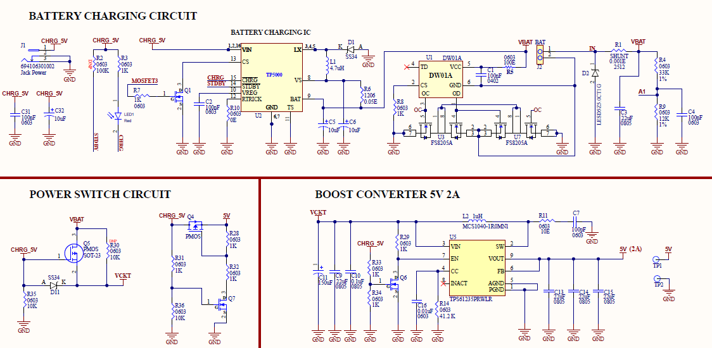

Multimeter measurements (David, 30.09.2021) :
Voltage measured [Volts] (+,-) | PCB stand-alone mode with LiFePO4  WORKING  (light off) | PCB stand-alone mode with LiFePO4  NOT WORKING (light off) | charging mode, with LiFePO4 and 5V charger  WORKING  (light off) | Remarks
Vbat+, Vbat- | 3.26 | 3.30 | 3.44
Vbat+, GND | 3.26 | 3.30 | 3.48 | Batt protec. circuit OK
5V, GND | 5.25 | 2.47 | 4.76
CHRG_5V, GND | 0.00 | 2.47 | 4.80 | Q4 stay activated despite having nothing connected
Q5 pin2,pin3 (VDS) | 0.00 | -0.05 | 1.08
D11(K,A) | 3.26 | 0.77 | -0.23
Q7 pin1, pin2 VGS | 0.00 | 1.23 | 2.40
Q7 pin3, pin2 VDS | 5.25 | 0.00 | 0.02
VCKT, GND | 3.25 | 3.23 | 4.58
Q6 pin1,pin2 (VGS) | 0.00 | 1.23 | 2.40
Q6 pin3,pin2 (VDS)  (Boost EN) | 3.26 | 0.00 | 0.00 | Boost not activated by the power switch

